** Bansilal Ramnath Agarwal Charitable Trust’s**

**Vishwakarma Institute of Information Technology, Pune-48**

**(An Autonomous Institute affiliated to Savitribai Phule Pune University)**

**Department of Computer Science and Engineering (Artificial Intelligence)**

**LAB SUBMISSION**

**Data Science and Machine Learning**

**CAUA22201**

*Submitted by:*

*Avdhoot Nilesh Pimparkar,*

*PRN: 22210178,*

*Roll Number: 281054*

*Second Year*

*Semester II Academic Year 2023-24*

**Assignment: 7**

Aim: To implement Classification techniques for following scenario:

Every year many students give the GRE exam to get admission in foreign Universities. The

data set contains GRE Scores (out of 340), TOEFL Scores (out of 120), University Rating

(out of 5), Statement of Purpose strength (out of 5), Letter of Recommendation strength (out

of 5), Undergraduate GPA (out of 10), Research Experience (0=no, 1=yes), Admitted (0=no,

1=yes). Admitted is the target variable.

The counselor of the firm is supposed to check whether the student will get an admission or

not based on his/her GRE score and Academic Score. So to help the counselor to take

appropriate decisions, build a machine learning model classifier using a Decision tree to

predict whether a student will get admission or not.

a) Apply Data pre-processing (Label Encoding, Data Transformation....) techniques if

necessary.

b) Perform data-preparation (Train-Test Split)

c) Apply Machine Learning Algorithm

d) Evaluate Model.

Theory:

A decision tree is one of the most powerful tools of supervised learning algorithms used for both classification and regression tasks. It builds a flowchart-like tree structure where each internal node denotes a test on an attribute, each branch represents an outcome of the test, and each leaf node (terminal node) holds a class label. It is constructed by recursively splitting the training data into subsets based on the values of the attributes until a stopping criterion is met, such as the maximum depth of the tree or the minimum number of samples required to split a node.

During training, the Decision Tree algorithm selects the best attribute to split the data based on a metric such as entropy or Gini impurity, which measures the level of impurity or randomness in the subsets. The goal is to find the attribute that maximizes the information gain or the reduction in impurity after the split.

The decision tree operates by analysing the data set to predict its classification. It starts from the tree’s root node, where the algorithm views the value of the root attribute compared to the attribute of the record in the actual data set. Based on the comparison, it proceeds to follow the branch and move to the next node. There are two popular techniques for Attribute Selection Measure (ASM), which are: Information Gain and Gini Index.

The algorithm repeats this action for every subsequent node by comparing its attribute values with those of the sub-nodes and continuing the process further. It repeats until it reaches the leaf node of the tree. The complete mechanism can be better explained through the algorithm given below.

Step-1: Begin the tree with the root node, says S, which contains the complete dataset.

Step-2: Find the best attribute in the dataset using Attribute Selection Measure (ASM).

Step-3: Divide the S into subsets that contains possible values for the best attributes.

Step-4: Generate the decision tree node, which contains the best attribute.

Step-5: Recursively make new decision trees using the subsets of the dataset created in step -3. Continue this process until a stage is reached where you cannot further classify the nodes and called the final node as a leaf node Classification and Regression Tree algorithm.

Here is the dataset that we have used:

“<https://www.kaggle.com/mohansacharya/graduate-admissions>”

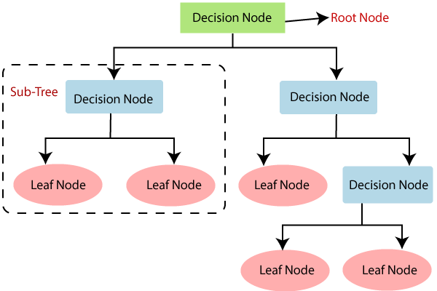

Fig. Decision Tree

Advantages:

1. It is simple to understand as it follows the same process which a human follow while making any decision in real-life.
2. It can be very useful for solving decision-related problems.
3. It helps to think about all the possible outcomes for a problem.
4. There is less requirement of data cleaning compared to other algorithms.

Limitations:

1. The decision tree contains lots of layers, which makes it complex.
2. It may have an overfitting issue, which can be resolved using the Random Forest algorithm.
3. For more class labels, the computational complexity of the decision tree may increase.

Results:

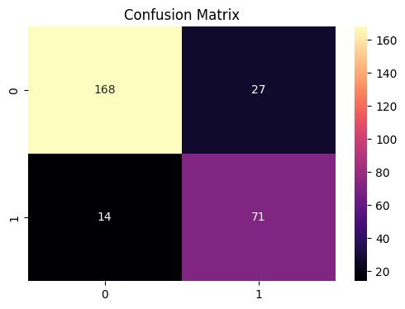

Fig. Confusion Matrix

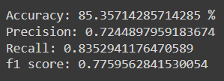

Fig. Classification Report

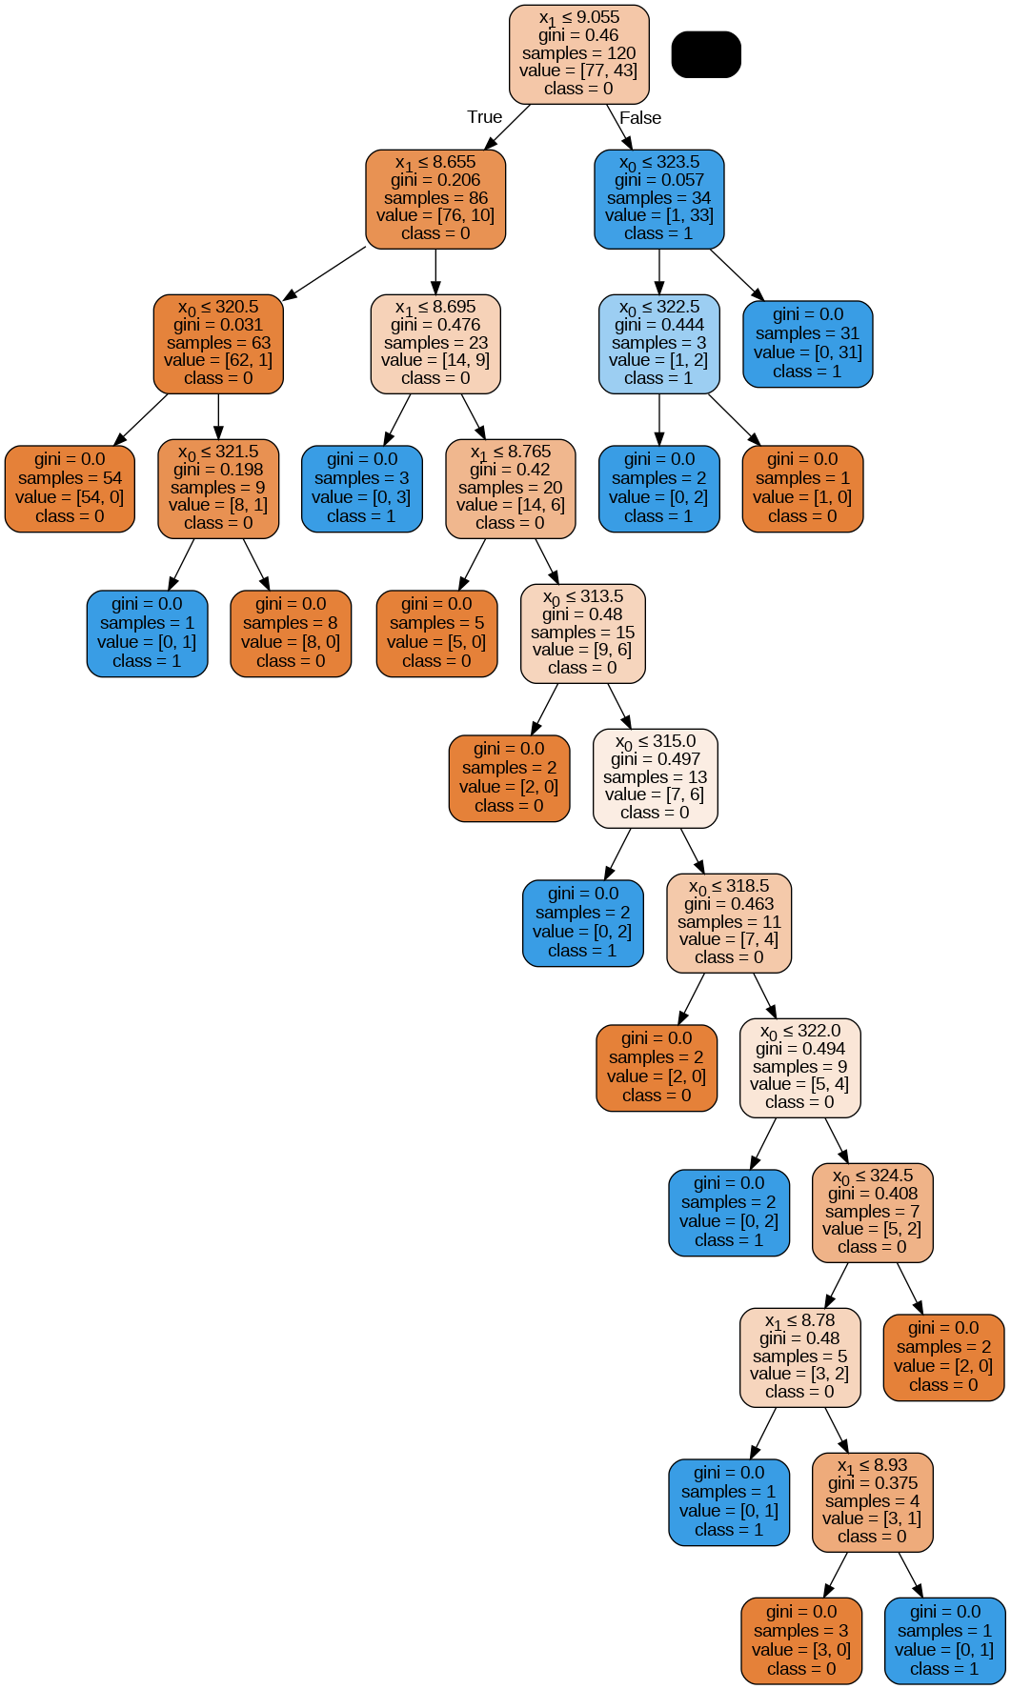

Fig. Decision Tree Model

Conclusion:

In this assignment, we were able to learn about Decision Tree Classifier and various terminologies related to it like Entropy, Information Gain and Gini Index.